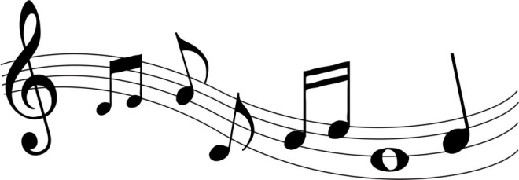
St. Francis of Assisi’s Children’s Choir
Music Camp

When: August 24 – 28
What time: 9:30 am – 11:30 am
Where: St. Francis of Assisi Chapel
Children in Grades 1 – 8 may participate

Start the NEW School Year on a happy note!
Come and learn new singing techniques and learn to play the bells as well. The Camp will also focus on Rhythm Instruments and playing and singing together as one!

This is also a trial run for Children’s Choir! Come and check out whether singing and playing instruments is for you!! The first Mass of the year is Sunday, September 13 at 11:00 am. You do not have to join Children’s Choir to come to Camp. Camp is open to all children. Friends from other Churches are welcome to participate as well! Music is a great way to discover new things about you and make new friends!

Interested? Contact Mary Knoerl
knoerl@juno.com or Message me on Facebook
Call – 716 – 868- 1749, text or leave a message, I will get back to you promptly!

Come and make a joyful noise unto the Lord!!

