September GOF Home Kit – Faith starts at HOME!!!

A MEAL OR ANYTIME PRAYER TO HELP US LEARN THE MASS!
“It is truly right and just, our duty and our salvation, always and everywhere to give you thanks, Father of mercies and faithful God, For you have given us Jesus Christ your Son as our Lord and Redeemer. He always showed compassion for children and for the poor, for the sick and for sinners, and he became a neighbor to the oppressed and the afflicted. By word and deed he announced to the world that you are our Father and that you care for all your sons and daughters. Amen.”
~taken from the Eucharistic Prayer for Various Needs IV
A SHORT COVERSATION WITH GOD
O God, we come to you with praise and thanksgiving on our lips for you have remained faithful to us down through the ages. When we have fallen down, you have picked us up. When we have fallen short, you have forgiven us and taken up the slack. When we have fallen for false gods, you have gently beckoned us back to you. We are grateful to be your people and ask you to never forget us. Amen.

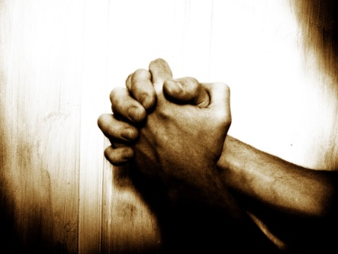
THE OUR FATHER
Our Father, Who art in Heaven, hallowed be Thy name; Thy Kingdom come, Thy will be done on earth as it is in Heaven. Give us this day our daily bread; and forgive us our trespasses as we forgive those who trespass against us; and lead us not into temptation, but deliver us from evil. Amen.

THE HAIL MARY
Hail, Mary, full of grace, the Lord is with you. Blessed are you among women, and blessed is the fruit of your womb, Jesus. Holy Mary, Mother of God, pray for us sinners now and at the hour of our death. Amen.

Act of Contrition
My God, I am sorry for my sins with all my heart. In choosing to do wrong and failing to do good, I have sinned against you whom I should love above all things. I firmly intend, with your help, to do penance, to sin no more, and to avoid whatever leads me to sin. Amen.

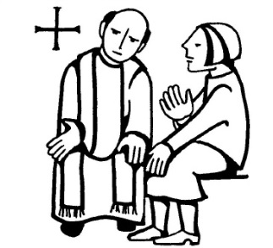
Why the Sacrament of Reconciliation??

Reconciliation or Confession brings great grace and peace to our lives! Often times, we shy away from the sacrament because it seems too scary or even strange! Why must we confess our sins (at least the serious ones) to a priest? Why is it not enough to confess them directly to God (Jesus)? First note that Catholics do not tell their sins to a priest "instead of to God," but to God through a priest, appointed by our Lord as an official stand-in for Christ.

Three basic Scripture passages underlie this practice:
1) Matt 16:18-19 "And so I say to you, you are Peter, and upon this rock I will build my church, and the gates of the netherworld shall not prevail against it. I will give you the keys to the kingdom of heaven. Whatever you bind on earth shall be bound in heaven; and whatever you loose on earth shall be loosed in heaven."
2) Matt 18:18 "Amen, I say to you, whatever you bind on earth shall be bound in heaven, and whatever you loose on earth shall be loosed in heaven."
3) John 20:21-22: Jesus said to them again, "Peace be with you. As the Father has sent me, so I send you." And when he has said this, he breathed on them and said to them, "Receive the holy Spirit. Whose sins you forgive are forgiven them, and whose sins you retain are retained."
During his life-time Christ forgave sins. Since he would not always be with the Church physically and visibly, Christ delegated this power to other men so that the Church would be able to offer forgiveness to future generations. He gave this as a communicable power to the apostles so it could be passed on to their successors, the bishops. In this passage (Jn 20:21-22) Jesus is telling the apostles to follow his own example, in delegating the power to the apostles to forgive sins.
Note that all of this is God's doing. It is He who, through Christ, has reconciled us to himself, and allowed us to minister this reconciliation of his to others (2 Cor 5:18). Indeed, confirms Paul, "We are Christ's ambassadors" (2 Cor 5:20). Note also that in the anointing of the sick described in Js 5:13-15-16, it is to the presbyters of the Church the person is to be brought, and his sins will be forgiven. It is to the ordained that the sick are brought. "Therefore, confess your sins to one another and pray for one another, that you may be healed. The fervent prayer of a righteousness person is very powerful."

Benefits of doing this the Catholic way
First, the Catholic is seeking forgiveness the way Christ intended it to be sought.
Second, by confessing to a priest, the Catholic learns a lesson in humility which is conveniently avoided when one confesses only through private prayer. Don’t we all desire to escape humbling experiences? OVER ->
Third, the Catholic receives sacramental graces that the non-Catholic does not get; through the sacrament of penance, not only are sins forgiven, but graces are obtained.
Fourth, and in some ways the most important, the Catholic is assured that his sins are forgiven; he doesn’t have to rely on a subjective “feeling.”
Fifth, the Catholic can obtain sound and objective advice in analyzing his sins and avoiding sin in the future.
Sixth, the Catholic, by going to a recognized and trained confessor, is protected against the subjective dangers of such psychological tricks of the personality such as projection, rationalization, etc.
So should I go?? It’s so awkward…
Yes! Unequivocally – YES!! It is SO good for you! And the MORE you go, the more natural and stress-less it becomes!!
WHEN?? EVERY SATURDAY, here at St. Francis, we have confessions from 3-4.
If you can’t make that, St. Amelia has Sunday confession at 8:30 & 10:30am, St. Timothy’s Sundays at 7:30pm, and St. Andrew’s M-F from 11:30-11:45.

Examination of Conscience  - Have I loved God above all things?  - Have I used the name of Jesus or God in anger or improperly?  - Have I attended Mass on Sundays and Holy Days?  - Have I respected my parents, superiors and those around me?  - Have I harmed others with my words or my actions?  - Have I been pure in thought, in my words and deeds?  - Have I cheated or stolen?  - Have I spoken unkindly about others or gossiped.  - Have I been a good friend to others?  - Have I been jealous of the things others have? | Examination of Conscience - Have I loved God above all things? - Have I used the name of Jesus or God in anger or improperly? - Have I attended Mass on Sundays and Holy Days? - Have I respected my parents, superiors and those around me? - Have I harmed others with my words or my actions? - Have I been pure in thought, in my words and deeds. Do I stay away from pornography? - Have I cheated or stolen? - Have I spoken unkindly about others or gossiped. - Have I been a good friend to others? - Have I been jealous of the things others have? Sacrament of Reconciliation Bless me Father for I have sinned, my last Confession was ______ ago. These are my sins. [Confess sins here] Act of Contrition My God, I am sorry for my sins with all my heart. In choosing to do wrong and failing to do good, I have sinned against you whom I should love above all things. I firmly intend with your help, to do penance, to sin no more and to avoid whatever leads me to sin. Amen  Sacrament of Reconciliation  Bless me Father for I have sinned, my last Confession was ______ ago. These are my sins. [Confess sins here]  Act of Contrition  My God, I am sorry for my sins with all my heart. In choosing to do wrong and failing to do good, I have sinned against you whom I should love above all things. I firmly intend with your help, to do penance, to sin no more and to avoid whatever leads me to sin. Amen

<- Take this with you: your CHEAT SHEET!
(not necessary to confess THIS cheating!!!)

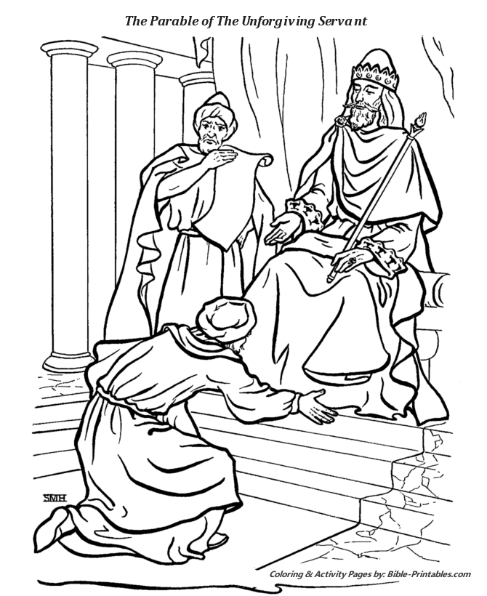

Fall & Winter 2017-18 GOD stuff!
Small Groups and more at St. Francis – You Were Created for THIS!!
Sign up: turn in this sheet, go to our website www.stfrancistonawanda.org/small-groups, look on back!
Mother’s and Father’s Prayers – Parents and their children are welcome to come together weekly to pray for their families and share their lives. Tuesday mornings at 9am in the St. Clare Center nursery.
Name & Phone ________________________________________________________________________________
Exploring Sunday Scripture - Get the MOST out of Weekend Mass - Reading and discussing the upcoming weekend scriptures opens a WHOLE NEW WORLD! Meet new friends and enjoy mass in ways you never dreamed possible!! Wednesdays 10:30-noon in the Rectory or Chapel -ongoing. Facilitators – Jim and Joan Jaskowiak
Name & Phone __________________________________________________________________________________
Financial Peace University – Applying God’s Word to your Money - This nine week class will show you how do get rid of debt, spend and save wisely, and more. Day and time to be announced . There is a fee for materials of $95, however, please see us if you need assistance. Put your name and number below and we will contact you. Facilitator – Kaitlyn Hils
Name & Phone _____________________________________________________________________________
Women’s Book Club – Monday evenings in the St Clare Center from 7:30-9:00pm - Ongoing. – Monday, September 18th begins our new book, The Divine Dance by Richard Rohr! Sign up or just show up!
Name & Phone _____________________________________________________________________________________
Women’s Prayer Group – Tuesday evenings in the St Clare Center from 7:00-8:30pm - Ongoing. – We are the prayer warriors of St. Francis Parish! Sign up or show up!
Name & Phone _____________________________________________________________________________________
“Fan the Flame - 101” - Young Adult, teen, and “Older Young Adult” Bible Study, coffee & Bagels – We will begin studying the gospel of Matthew this fall. Sundays with no GOF or Neighborhood Angels & Saints [so twice a month] from noon – 1:15 in the 101 room, St. Clare Center.
Name & Phone ________________________________________________________________________________
Gathering for families of newly baptized or preparing for baptizing children – We gather as families to celebrate as well as learn more about what Baptism really is and how to tap into it’s great power in our lives! One Wednesday evening a month – Next one is September 20th from 5:30-7:30 in the St. Clare Center. Children welcome – childcare available! Dinner will be served. RSVP’s appreciated!
Name & Phone __________________________________________________________________________________
Prayer Shawl Ministry – To join our group of knitters/crocheters please joins us once a month on the second Monday evening of the month or knit at home and drop off at the rectory, or call and someone will pick it up. Contact Ceil Sharp at 639-7945 for more information or leave your name and number below
Name & Phone __________________________________________________________________________________
Young Life- High School youth group. No cost fun as well as an opportunity to examine your faith.
- Tuesday nights starting October 3rd from 8-9:30pm in the St. Clare Center, 2nd floor
- Friday mornings, 6:30am at 25 Linwood Ave [Sue Ann & Michael’s house] for breakfast and bible study. Rides are provided to school
Wyldlife - Middle School youth group. Meets twice a month on Saturdays from 7:15-9:30. Schedule to be determined.
If you wish to be contacted about the youth groups, leave your name and number below. Feel free to contact us with any additional questions.
Name & Phone _____________________________________________________________________________
XLT -Spend time in prayer and worship at XLT (Exult). Leave refreshed and renewed! Next one is from 7:30-9 on October 6th in the Chapel. Come for adoration, worship and a teaching! OVER->

Exercise to the rosary!
Check it out – every Saturday at 8am in the Chapel and every Wednesday at 9am in St. Clare 101 room (childcare available on Wednesdays!) as well as most Mondays at 7am in 101. (text Sue Ann 716-909-7110) Bring hand weights and a mat if you have them.
Discovering Christ
Join us for an exciting new 7-session series!
We will gather to share a delicious dinner, listen to a dynamic teaching, and explore answers to some of the most important questions worth asking about God and finding ultimate purpose in life.

NOTE: Attending this course is an opportunity for adults who never made confirmation and wish to make the sacrament this Easter!!
Wednesday evenings, Sept 27, Oct 4,11,18,25 Nov 1,8
from 6:30-9:00 PM.
St. Clare Center Hall, 144 Broad St, Tonawanda
Dinner and program offered at no cost. Childcare provided
Name & Phone _______________________________________
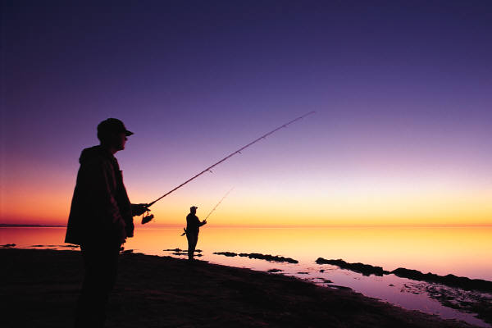
What gives ultimate meaning and purpose to life?
Is there a way to be truly happy in life?
How can I begin a better life?

Tired of just fishing for answers?
Do you or does someone you know have questions about Baptism or catching up on Communion or Confirmation? Contact us OR provide
Name & contact info _________________________________________________________________________
Is there a small group you’d like to see? Do you have any suggestions? Please let us know below:
_______________________________________________________________________
Would you like to volunteer at St. Francis?
Contact info: ______________________________________________________________________
Neighborhood Angels and Saints I
Join us the first Sunday of every month
(except December – no NAS and April when it’s the 2nd Sunday) to make a homemade meal like soup and bread for homebound and those in need in our community. Come to the Adam Street cafeteria after the 11 o’clock Mass to help! Drivers are needed at around 3 to deliver, too! Next one is October 1st.

Tired of just fishing for answers?
Contact Information
[call or text]
Sue Ann Saltarelli Michael Saltarelli
716-909-7110 716-830-0320
Sueann60@gmail.com mikesalts@gmail.com
website
Stfrancistonawanda.org/faith-formation

GREAT talks for adults on FORMED.ORG:
(Highlighted talk is your HW for September – Kids’ selection on reverse side!)
- Living the Gospel with the Heart of Pope Francis
- Who Am I to Judge
- Religionless Spirituality
- From Atheism to Catholicism – My Conversion Diary
- That All May be One
- Saints for Sinners
- Blessed Pier Giorgio
- I’m Not Being Fed
- The Healing Power of Confession
- We Must Go Out
- Facing Your Fears
- The Four Levels of Happiness
- Discerning God’s Will
- Being All In
- Is God on your iPod?

Not on FORMED.ORG?

Go to the website (it seems to work better initially from a computer) and click “REGISTER”.
Type in our parish code:
ZKZ79Y – all caps
You will be directed to go to your email and verify that you’re registering.
Then you will make a login (your email address and a password).Remember – YOU WILL ONLY USE THE PARISH CODE THE FIRST TIME to make a login. The next time you log on, it will be your email and password.
KIDS’ HW for September:
Watch “The Day the Sun Danced – The True Story of Fatima”

